Create a shell script to print the HTTP error code of guvi.in & print, the success/failure message based on the error code response

SHELL SCRIPT :
A shell script is a file containing a series of commands for the shell to execute. The shell itself is a command-line interpreter (CLI), while a shell script is a saved list of instructions (usually with .sh extension) like myscript.sh.
USES OF SHELL SCRIPT:
Shell script turn routine jobs like file cleanup , backups or server updates into one click actions, saving time and reducing manual effort
AUTOMATE REPETITIVE TASKS

Shell scripts it easy to link different commands together , it can pass the output of one command to another , filter data, or run task step by step all in one script, this helps to automate complex jobs using simple building blocks
LINKING COMMANDS TO WORK TOGETHER
NATIVE SUPPORT ON LINUX SYSTEMS
Shell scripting is natively supported on unix based systems requiring no additional installations. The shell environment like zsh, bash is preinstalled allowing scripts to run seamlessly across most linux distributions and unix like os
It can count on it to perform tasks consistently its setting up servers , cleaning up files, running a deployment , that removes error and predictable results
RELIABLE & CONSISTENT
IN DEVOPS, they are widely used to speed up deployment and manage infrastructure without doing everything manually
DEVOPS & MONITORING

They are interpreted there is no compile step it can write a useful script in minutes, and test in instantly perfect for quick fixes and small tasks.
EASY TO WRITE

SHELL SCRIPTS INCLUDES :

A Shell keyword are also known as reserved word with a special meaning and functions within the shell syntax, serving as building block.

Shell keywords :

- If, then , else , fi : used for a conditional execution & branching

- For , in , do, done : used to create loops that iterate over a list of values.

- While , until : used for loops structures that continue based on specified conditions

- Case, esac : used for multi way branching based on a variables value

- Function : used to define functions, which are blocks of reusable code.

- Return : used to exit a function and potentially return a value.

Shell commands :

A Shell command is an instruction given to a computer operating system through a command line interface it is text based way of interacting with the computer, allowing users to perform various task without the need for the graphical user interface.

- Cd : its used to change the directory

- Ls : its used to list directory contents

- Cp : its used to cpy the files

- Mv : its used to move or rename the files

- Rm : its used to remove the files

- Mkdir : its used to create the directory

- Ping : its used to check the network connectivity

Shell control flow:

Shell control flow refers to the mechanism within a command shell (zsh, bash or csh) that allows to dictate the order of execution of the commands and statement within a shell script or even on the command line.

- Conditions : (if / elif / else ):
it allows the shell to execute different blocks of code based on whether the condition is true or false.

- Loops ( for / while / until ) :
It enable the repetition of block of commands multiple times

- Break & continue : its used within loops to alter their executions

Break : exits the current loop entirely
Continue : skips the remaining commands in the current iteration of the loop and proceeds to the next iteration.

- Functions :
Functions allow for modularity and code reuse , which indirectly influences the flow of script by defining reusable blocks of commands,.
Count = 0
While [ $count -lt 5]; do
Echo “count : $count”
Count=$((count + 1))
done

UTILITIES SHELL KERNEL HARDWARE

FLOW CHART OF SHELL SCRIPTING:
START

RETURN CODE =0
IF LIST A

FALSE

RETURN CODE =0 TRUE

THEN LIST B

OTHER COMMANDS
FI
Coding
#!/bin/bash

#Define the URL to check
URL=”https:www.guvi.in”

#use curl to get only the HTTP status code
# -s: silent mode, suppresses progress meter and error messages
# -o /dev/null : discard the response body
# -w “%{HTTP_code}”: print only the HTTP status code
Http_code =$(curl -s -o /dev/null -w “%{http_code}” “$URL”)

Echo “http status code for $URL : $Http _code”

# check the HTTP status code and print a message

If[[“$http _code”=~^2[0-9]{2}$]]; then
Echo “success : the website is accessible and returned a successful status code .”
Elif [[“$http_code”=~^3[0-9] {2}$]]; then
Echo : “informational/redirection : the website returned a redirection status code.”
Elif [[“$http_code”=~^4[0-9]{2}$]]; then
Echo : “ failure : client error - the website returned a client error status code.”
Elif [[“$http_code”=~^5[0-9]{2}$]]; then
Echo : “failure: server error - the website returned a server error status code.”
Else
Echo “failure : An unexpected HTTP status code or an error occurred during the request .”
Fi

Given a file, replace all occurrence of the word "give" with "learning" from 5th line till the end in only those lines that contain the word "welcome"

Replace all occurrence of the word “give “ with “learning” .

- Replacing an entire file :

Using cp (copy) : this command copies a source file and overwrites an existing destination file.

Code :
Cp -f /path/to/source_file/path/to/destination_file

- Replacing text within a file:

Using sed (stream editor): this command is powerful for finding and replacing text using regular expressions.

Code :

Sed -I ‘s/old_text/new_text/g’ /path/to/filename

Explanations:

- -i : modifies the file in place.
- S : is the substitute command.
- Old _text : is the pattern to search for
- New_text : is the replacement text
- G : ensure all occurences on a line are replace (global replacement)

File systems:
User applications

Inode cache
Virtual file system
Individual file system
Buffer cache
Device drivers
Directory cache
System call interface
GNU C LIBRARY

Mount point for temporary a mounting file systems
Mount point for removable media devices
Shared libraries and kernel modules
Home directories for individual users
Host specific system configuration
MNT
MEDIA
LIB
HOME
ETC
Device inode files
DEV
Static files of the boot loader
BOOT
Essentially the binaries
BIN
Additional application software packages
Essential system binaries
Temporary files
Secondary hierarchy
Variable data
Home directory for the root
Data relevant running processes
OPT
RUN
ROOT
SBIN
TMP
USR
VAR

SED COMMAND IN LINUX TO USE REPLACE THE WORD “GIVE WITH LEARNING”

The SED command in linux, shorts for stream editor is an non interactive text editor used to perform basic text transformations on an input stream such as file or input from a line text, it processes the text line by line, applying the editing commands .

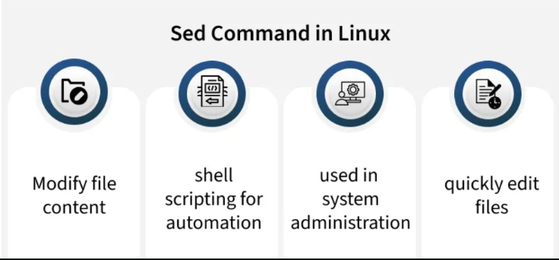

SYNTAX :

Sed -I ‘s/give/learning/g’ file name
Explanation of the command :

- Sed : this invokes the stream editor a powerful text manipulation tool

- -i: this option specifies the change should be made in place directly to the file name without -I sed would print the modified content to standard output

- ‘s/give/learning/g’ : substitution command within sed

- /give/: this is the pattern search for the word give

- S: this indicates the substitute command

- /learning/: this the replacement string

- /g: this is the global flag ensures that all occurences of give on each line are replaced not just first one

- Filename : this is the name of the file where the replacements should be performed.

Example programmings :

Sed ‘1,4b; /welcome/ s/give/learning/g’ input.txt > output.txt
Explanations :

- 1,4b : skip first 4 lines (no changes)

- /welcome/s/give/learning/g : from line 5 onward , if the line contains “welcome” perform the replacement globally

- Result goes to output.txt

OUTPUT.TXT

- HELLO
- GIVE & TAKE
- WELCOME EVERYONE
- PLEASE GIVE
- WELCOME
INPUT.TXT

- HELLO
- GIVE & TAKE
- WELCOME EVERYONE
- PLEASE GIVE
- WELCOME

